**SDOT RSJI Independent Study - Reflection Guide**

Statement of Purpose:

The Race and Social Justice Initiative (RSJI) supports SDOT’s mission that through our work we will end institutional racism, biases, and inequity in our transportation system, workforce, and intersections with institutionally racist systems.

The RSJI Independent Study option is intended to meet the varying needs of SDOT employees at every level and to offer the opportunity for staff to engage with race and social justice topics through more flexible means.

This Reflection Guide is intended be used as a tool to inspire deep personal growth and as an assessment on how SDOT as an whole is moving forward toward being a truly equitable, just, and anti-racist institution. One person at a time, we are building our collective capacity to understand the context that shaped our current world and to understand what it takes to undo unjust practices that have historically been imbedded in government institutions.

The work of the Change Team and the RSJI are rooted in the anti-racist principles from the People’s Institute for Survival and Beyond.

We encourage you to review those principles here [www.pisab.org/our-principles](http://www.pisab.org/our-principles)

|  |  |
| --- | --- |
| Employee Name: | Employee ID Number: |
| Racialized identity: | Pronouns (optional): |

|  |  |
| --- | --- |
| Supervisor/Manager Name: | Date Completed: |
| Title of Content: | Length (hours, round to nearest ½ hr): |
| URL Link: | Type of Content (ie. Book, article, online training or workshop, discussion group, webinar, podcast, video or film, etc.): |

Steps:

A.) **Who are you?** Reflect on your own racial identity *before taking time to watch, listen, or participate in your Independent Study material.*

B.) **Where are you?** Use the Becoming Anti-racist graphic to visualize where you are in your racial justice journey *before taking time to watch, listen, or participate in your Independent Study material.*

C.) **Do the work:** watch, listen, or participate in the RSJ resource you chose. Circle which RSJ topic(s) was covered.

D.) **Reflection Questions:** answer 5. You can submit a written, voice or video recording, or illustration as a response.

E.) **Becoming Anti-racist:** where are you now?

F.) **Submit your Reflection Guide** to [DOTRSJ@seattle.gov](mailto:DOTRSJ@seattle.gov) . Forms will be reviewed by key members of the Change Team and OEEI.

G.) Consider signing up for a **Discussion Session** on Cornerstone (dates TBD) to share knowledge and engage in a dialogue with your SDOT peers.

Logistical Notes:

* Length: This is the total amount of time spent including time it takes to consume the content (ie. watch the video, read the article, listen to the podcast, etc.) and complete the Reflection Guide. Although 2 hours is the time needed to receive credit, it is encouraged to take as much time as you need to complete the Reflection Guide.
* There is a RSJI Glossary at the back of the guide for your reference
* Independent Study is to be completed on work time and should be approved by your supervisor
* Let us know how this Reflection Guide can be improved! This guide is a living document and your feedback greatly helps us help you.

**A. Who are you?**   
We come from many different backgrounds, cultures, and ways of socialization that influence our individual actions, behaviors, and values. Describe your current understanding of your racialized identity within the United States context. Feel free to use as many or few words as needed.

You can use the diagram below to frame your response with the self in the center within an institution which operates within a cultural norm.

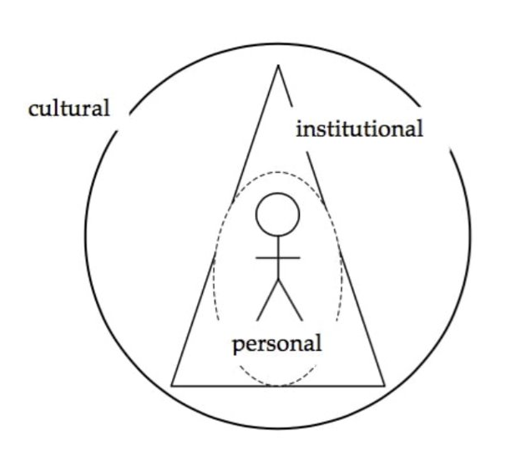  
From dRworks workbook - <www.dismantlingracism.org>.

**B. Where are you?**   
Circle the sentences that apply to you...

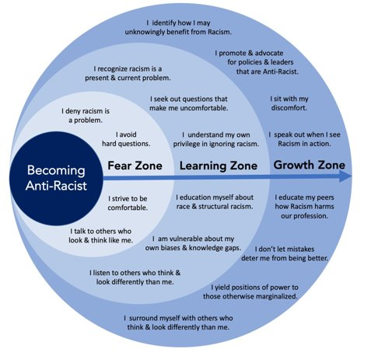  
Dr. Ibram X. Kendi & Graphic: Dr. Andrew M. Ibrahim

**C. Which aspects of RSJI were covered?**   
Check all that apply. **Refer to the RSJI Glossary for definitions**

|  |  |  |
| --- | --- | --- |
| Workforce equity | Community Development | Government Policies |
| Race and racism | Environment | Culture |
| Immigration | Anti-racist principles and practices | Intersectionality Identities (gender, sexuality, race, etc.) |
| Education | Housing | Criminal Justice |
| Anything else? |  |  |

**D. Reflection Questions**  
***Respond to at least 5 of the prompts below. You can respond in written form, video or voice recording, or illustration.***

1. What emotions are you feeling after digesting this content?
2. What new or helpful information did you learn about Race and Social Justice in America?
3. What new anti-racist principles or practices did you learn? Are there any new terms/definitions that you learned?
4. What felt familiar to you? Is there a particular subject or topic you learned that resonated with you?
5. How does the content show up in your life (ie. At home, at work, interacting with the public, etc.)? What dynamics arise when applying a racial justice and social justice lens to your life at home, at work, and interactions with the public?
6. Was there anything brought up that you are struggling to understand? Was there anything in the content where you felt resistant? Why? How would you challenge these notions?
7. What are some things you learned that you would like to share with others in your life (coworkers, family members, etc.) on your team at SDOT?
8. How do you think this content relates to the people who you are close to?
9. What questions do you have about the content?

**E. Where are you now?**   
Circle the sentences that apply to you.



**F**. Thank you for taking the time to partake in remote learning of intensely personal and sensitive issues around race and social justice. **Submit your Reflection Guide** to [DOTRSJ@seattle.gov](mailto:jessica.kim@seattle.gov)

**G.** We encourage you to register for a Discussion Session in Cornerstone (date TBD) to meet with other SDOT employees to share knowledge and continue the journey towards our mission to dismantle institutional racism.

**Glossary for SDOT’s Race and Social Justice Initiative**

**Anti-racist:** To actively behave in ways and participate in efforts to undo oppressive forces that exist due to racism.

**Bias**: Prejudice against or in favor of an individual or group, usually based on attributes like race, gender, religion, sexual orientation, etc.

* **Explicit bias**: Conscious attitudes or stereotypes that shape our actions. Explicit biases lead us to discriminate against someone based on that person’s identity.
* **Implicit Bias:** Unconscious attitudes or stereotypes that shape our actions. Implicit biases begin to develop at a very early age through exposure to media, schools, government, religious institutions and our families and friends. Our conscious beliefs and statements do not necessarily reflect our implicit biases.

**Change Team**: A group of employees within each City department that supports the department’s RSJI goals and helps to implement its annual RSJI work plan. The size, organization and specific responsibilities of Change Teams vary by department.

**Contracting equity**: Racially equitable outcomes in the City of Seattle’s use of its financial resources, including goods and services, consultants, and other forms of contracting.

**Cultural Supremacy:** A set of rules, norms, values and standards of acceptance that creates a set of expectations (both implicit and explicit) that work to the benefit of those who identify or subscribe to these ideologies and to the detriment of those who do not fit the status quo.

**Decolonization:** The undoing of colonialism, the latter being the process whereby a nation establishes and maintains its domination on territories.

**Discrimination:** The unjust or prejudicial treatment of different categories of people, especially on the grounds of race, age, gender, abilities, sexual orientation, etc.

**Equity and equality**: **Equity** means fairness of results; **equality** means equal access to opportunity.

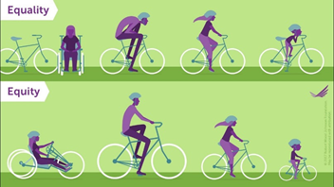

**Equity areas**: Important areas that the City of Seattle focuses on to achieve racial equity. Equity areas include education, health, equitable development, criminal justice, jobs, housing, the environment and the arts.

**Gatekeeper**: Anyone who controls access to services, information, resources or political power in an institution like Seattle City government. Just about every government employee serves as a gatekeeper in large and small ways.

**Inquest:** An Inquest is NOT a trial or criminal proceeding. An inquest is a public forum to shed light on the circumstances around a police officer killing someone. Based on info from the inquest and other sources, the King County prosecutor decides if there is sufficient evidence to bring the officer to trial.

**Internalized Racial Oppression:** The acceptance of and acting out of an inferior definition of self, given by the oppressor, is rooted in the historical designation of one’s race. Over many generations, this process of disempowerment and disenfranchisement expresses itself in self-defeating behaviors.

**Internalized Racial Superiority:** The acceptance of and acting out of a superior definition is rooted in the historical designation of one’s race. Over many generations, this process of empowerment and access expresses itself as unearned privileges, access to institutional power and invisible advantages based upon race.

**Justice:** The basic idea can be elaborated in many ways, according to what goods are to be distributed – wealth, respect, opportunity – and who or what they are to be distributed equitably among – individuals, families, nations, races, etc.

**Police brutality:** A civil rights violation that occurs when a police officer acts with excessive force by using an amount of force with regards to a civilian that is more than necessary. Excessive force by a law enforcement officers is a violation of a person's rights.

**Prejudice**: Preconceived opinion(s) and/or idea(s) that is not based on reason or actual experience. It causes harm or injury that results or may result from some action or judgment.

**Racial equity**: When a person’s race no longer predicts social, economic and political outcomes. Currently, racial inequities exist across all indicators for success in Seattle, such as income, health, education and involvement in the criminal justice system.

**Racial Equity Toolkit (RET)**: A set of questions to guide City departments and work teams to embed racial equity in policy, program and budget decisions. The RET helps City employees understand how our decisions benefit and burden different communities based on race. RET is a key part of the City’s efforts to achieve racial equity. It provides a practical tool to analyze our work and find ways to build in racial equity as part of the foundation of City programs and services.

**Race**: In the United States and other places, a social construct that divides people into different groups based on physical characteristics and supposed intellectual, psychological and social differences. Race has no scientific validity, yet it exerts profound influences on U.S. society and culture.

**Racial Anxiety:** The heightened levels of stress and emotion that we confront when interacting with people of other races. People of color experience concern that they will be the subject of discrimination and hostility. White people, meanwhile, worry that they will be assumed to be racist.

**Racism:** The belief that members of different races possess characteristics or abilities specific to those races. The goal of racism is to treat people better or worse based on the supposed inferiority or superiority of their races.

* **Individual racism**: Pre-judgment, bias or stereotypes about an individual or group, based on race.
* **Institutional racism**: Organizational programs, policies or procedures that work to the benefit of white people and to the detriment of people of color, often unintentionally or inadvertently.
* **Structural Racism**: Racism that plays out across multiple, interlocking institutions in a context of racialized historical and cultural conditions. Structural racism leads to negative outcomes and conditions for communities of color compared to white communities.

**Redlining:** A discriminatory practice targeted at African-Americans and others of color, where banks, insurance companies, and other institutions, refused or limited loans, mortgages, and insurance within specific geographic areas

**Restorative Justice:** A theory of justice that emphasizes repairing the harm caused by criminal behavior. It is best accomplished through cooperative processes that allow all willing stakeholders to meet, although other approaches are available when that is impossible. This can lead to transformation of people, relationships and communities.

**Whiteness:** a racial identity associated with Euro-colonial heritage and a tool to dominate social norms.